2001 September

Fundamental information technology Engineer Examination (Morning)

Questions must be answered in accordance with the following:
Question Nos. | Q1 to Q80
Question Selection | All questions are compulsory
Examination Time | 9:30-12:00 150 minutes
Instructions:
1. Use an HB pencil.
If you need to change an answer, erase your previous answer completely and neatly. Wipe away any eraser debris.
2. Mark your answers in accordance with the instructions below. Your answers will not be graded if you fail to comply with the instructions. Do not mark or write on the answer sheet outside of the prescribed places.
(1) Examinee Number
Write your examinee number in the space provided, and mark the appropriate space below each digit.
(2) Date of Birth
Write your date of birth (in numbers) exactly as it is printed on your examination admission card, and mark the appropriate space below each digit.
How to Mark Your Answers
(3) Answers
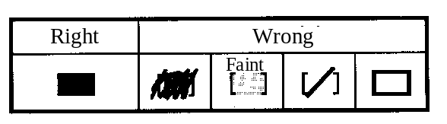
Select one answer (A through D) for each question.
Mark your answer as shown in the following sample
question.
[Sample Question] In which month is the Spring IT Engineer Examination conducted?

a) 2 | b) 3 | c) 4 | d) 5

Since the correct answer is "C" (4), mark your answer sheet as follows:

[Sample Reply]


Do not open the exam booklet until instructed to do so.
Inquiries about the exam questions will not be answered)

Company names and product names that appear in this test are trademarks or registered trademarks of their respective owners. Note that the ® and ™ symbols are not used within.
Q1. Of the following decimal fractions, which becomes an infinite binary fraction when expressed as a binary number?

a) 0.05 b) 0.125 c) 0.375 d) 0.5

Q2. Which of the following decimal numbers expresses the binary number 101.11?

a) 5.11 b) 5.3 c) 5.55 d) 5.75

Q3. When a certain integer value is converted to the binary representation in which a negative value is expressed as its two’s complement, the lowest two bits are “11.” Which of the following statements is true for the remainder that is produced when that integer value, in the decimal representation, is divided by 4? Here, assume that the decimal portion of the absolute value of the quotient of the division operation has been truncated.

a) The remainder is 3 if the integer value is positive.
b) The remainder is 3 if the integer value is negative.
c) The remainder is −3 if the integer value is negative.
d) The remainder is 0, regardless of whether the integer value is positive or negative.

Q4. How many bytes are needed in order to represent a signed six-digit decimal number as a packed decimal?

a) 3 b) 4 c) 6 d) 7

Q5. In floating point operations, what is the term for the phenomenon in which the number of digits in a significant figure decreases in a subtraction operation involving numbers that are close in value?

a) Truncation error b) Cancellation c) Information loss d) Rounding error

Q6. When the following operations were performed on two real type variables x and y, the value displayed in ③ has ceased to change. What is that value?

① 0 → x
② 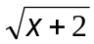→ y
③ Display value of y
④ y → x
⑤ Return to ②

a) 0 b) 1 c) 2 d) 4

Q7. The following diagram depicts daily changes in the weather in a given region. The numbers in the diagram indicate the probability of a change in the weather from the previous day. When it is rainy on a given day, what is the probability that it will be fine two days later?

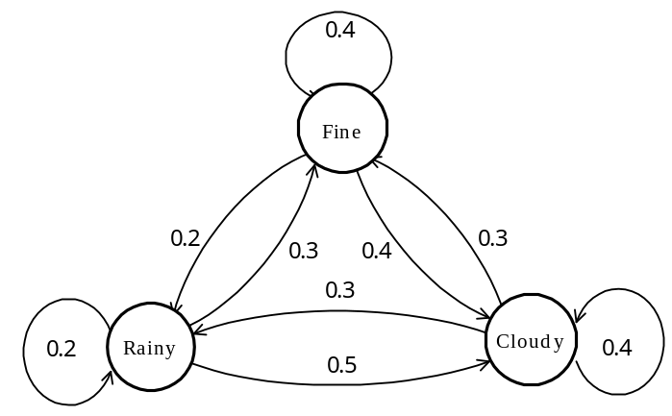

a) 0.15 b) 0.27 c) 0.3 d) 0.33

Q8. In an 8-bit code, how many cases are there where the number of 0 bits equals the number of 1 bits?

a) 16 b) 24 c) 70 d) 128

Q9. The distribution of weights of a product that is being mass produced at a certain factory was found to be a normal distribution with an average of 5.2 kg and a standard deviation of 0.1 kg. Products that weigh less than 5.0 kg are rejected during the company’s internal inspection process. What is the percentage of products manufactured at this plant that are rejected?

Standard normal distribution table
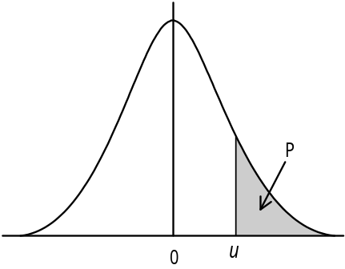
u | P
0.0 | 0.500
0.5 | 0.309
1.0 | 0.159
1.5 | 0.067
2.0 | 0.023
2.5 | 0.006
3.0 | 0.001

a) 0.1 b) 0.6 c) 2.3 d) 4.6

Q10. Given the bit strings x = 1100 and y = 1010, what operation yields the string 1011? Here, “AND,” “OR” and “” refer to logical product, logical sum, and negation of Z, respectively.

a) 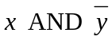 b) 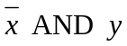 c) 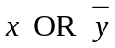 d) 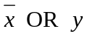

Q11. The following table is a state transition table for checking an input character string. This check rejects the string if the state is “e” after a character is inputted.
Assuming that the initial state is “a,” which of the strings shown below would be rejected when inputted? Note that the “” here is used to denote a space.

 |  | Input characters
 |  | Space | Numeral | Sign | Decimal point | Others
Current state | a  b  c  d | a  a  e  a | b  b  b  e | c  e  e  e | d  d  d  e | e  e  e  e

a) +0010 b) –1 c) 12.2 d) 9.

Q12. Which of the following binary trees is a binary search tree?

a) 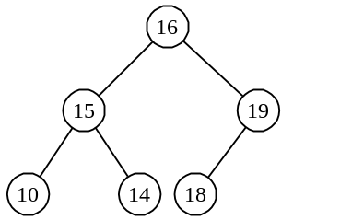 b) 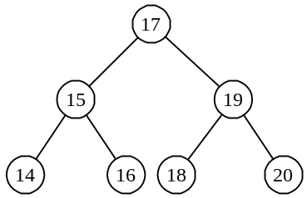

c) 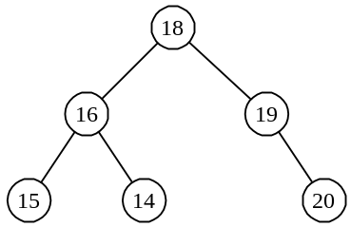 d) 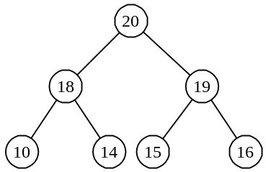

Q13. When using a bubble sort to sort “n” data elements, how many times will data elements be compared?

a) n log n b) n (n + 1) / 4
c) n (n − 1) / 2 d) n²

Q14. Awards for suggestions for improving work processes are determined according to the following table. What is the total combined award for Suggestion 1 and Suggestion 2?

Suggestion results in savings of up to $1000 | Y | Y | N | N
Suggestion results in schedule being shortened by up to one week | Y | N | Y | N
Award: $5.00 | X | – | – | –
Award: $10.00 | – | X | X | –
Award: $30.00 | – | – | – | X

[Suggestions for improving]
Suggestion for improving 1: Savings of $2,000, schedule shortened by three days
Suggestion for improving 2: Savings of $500, schedule shortened by two weeks

a) $15.00 b) $20.00 c) $35.00 d) $40.00

Q15. There are two integer type variables “A” and “B.” In order for the following two flowcharts to have the same effect, regardless of the values of “A” and “B,” what conditional expression must be inserted in [a]? Here, “AND,” “OR” and “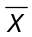” refer to logical product, logical sum, and negation of “X,” respectively.

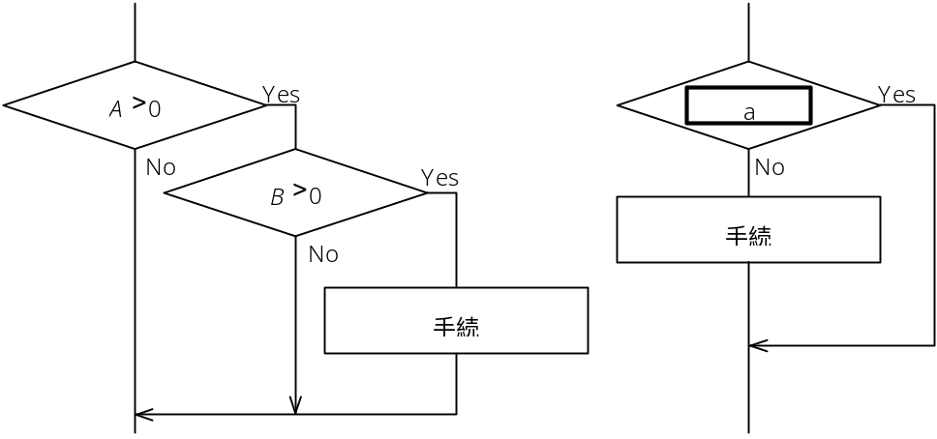
Procedures
Procedures

a) 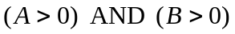 b) 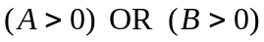
c) 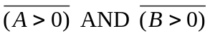 d) 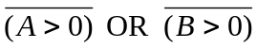

Q16. Which of the following types of memory allows data to be rewritten and erased electrically, and retains its contents even when the power is turned off?

a) DRAM b) SRAM
c) Flash memory d) Mask ROM

Q17. Which of the following circuits is used in memory cells in SRAM, has two stable states, and is a basic component of a sequential circuit?

a) AND (logical product) gate b) Adder
c) Multiplier d) Flip-flop
Q18. Which of the following logic circuits satisfies the following condition with one element?

[Condition]
Switches A and B at the top and bottom of a stairway turn a single light on and off. In other words, either switch can turn the light on or off, regardless of the position of the other switch.

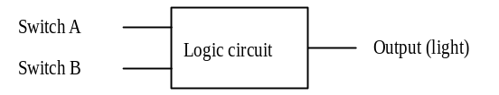

a) AND b) NOT c) OR d) XOR

Q19. Which of the following descriptions concerning the structure of an instruction is correct?

a) The number of operands is equal to the number of addresses in main memory specified by that instruction.
b) Although the length of the instruction word may vary with computer types, the length of the instruction word in any given computer is always constant.
c) The longer the instruction word is in a computer, the more different types of instructions can be included.
d) An instruction usually consists of an instruction code and an operand; some types of instructions, however, do not have an operand.

Q20. What is the average instruction execution time of a 50 MIPS processor?

a) 20 nanoseconds b) 50 nanoseconds
c) 2 microseconds d) 5 microseconds

Q21. Which of the following descriptions of the purpose of cache memory used in processors is correct?

a) Cache memory performs fast address translation for virtual storage.
b) Cache memory performs fast paging processing for virtual storage.
c) Cache memory compensates for the difference in speed between accesses to main memory and processing by the processor.
d) Frequently used programs are made resident in cache memory.

Q22. Which of the following terms describes a method reducing the effective access time by dividing main memory into several access units, and then using those access units in parallel whenever possible, as a means for making main memory faster?

a) Virtual memory b) Pipelining
c) Microprogram d) Memory interleaving

Q23. Assume a magnetic disk has a rotational speed of 5,000 rpm, and an average seek time of 20 ms. The recording capacity of one track on this disk is 15,000 bytes. What is the average access time (in milliseconds) required in order to transfer one 4,000-byte block of data?

a) 27.6 b) 29.2 c) 33.6 d) 35.2

Q24. In specifications for a magnetic disk, which of the following has a direct impact on rotational delay?

a) Recording density
b) Number of cylinders
c) Number of disk rotations per unit of time
d) Data transfer rate
Q25. Which of the following statements concerning CD-R disks is correct?

a) A CD-R cannot be read by a CD-ROM drive.
b) A CD-R can store more data than a CD-ROM.
c) A CD-R can be rewritten by reformatting it.
d) There are multiple formats for writing onto CD-R disks.

Q26. Which of the following descriptions of RAID 0 is correct?

a) A RAID 0 array consists of multiple expensive but highly reliable disks, and is intended primarily for having a large storage capacity.
b) The purpose of a RAID 0 array is to improve transfer rate by subdividing data and performing cyclically parallel I/O on multiple magnetic disks.
c) A RAID 0 array performs CRC error correction on each block without requiring redundant magnetic disks.
d) A RAID 0 array consists of multiple inexpensive magnetic disks under the control of the OS in order to provide reliability and higher performance.

Q27. Which of the following is the correct method of connecting devices to a PC using the USB (Universal Serial Bus) interface, a bus interface for peripheral devices? Here,  represents a USB peripheral device, and 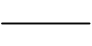 represents a cable.

a) 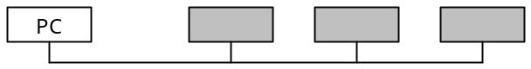

b) 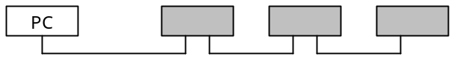

c) 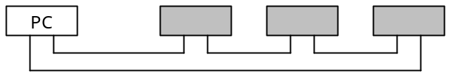

d) 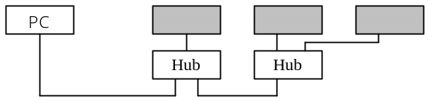

Q28. Which of the following is the EIA (Electronic Industry Association) standard for a physical interface between data terminal equipment (DTE) and data circuit terminating equipment (DCE), such as a modem, in a data communications system?

a) GPIB b) PCMCIA c) RS-232C d) SCSI

Q29. A processor consists of an arithmetic and logic unit and a control unit. Which of the following elements is part of the control unit?

a) Accumulator b) Adder
c) Complement register d) Instruction decoder

Q30. Of the following statements concerning the segmentation method and paging method for virtual memory, which one is a feature of the paging method?

a) The size of the region that is the basic unit of management for the virtual address space can be changed dynamically while a program is running.
b) Physical memory is used very efficiently, and region management is also simple.
c) Access to memory can be protected on a basis of logical units viewed by a program.
d) Modules can be fetched and shared easily while a program is running.

Q31. Which of the following descriptions of the LRU method in regards to page replacement algorithms is correct?

a) A method that replaces the oldest page
b) A method that replaces the page that was referenced last
c) A method that replaces the page whose elapsed time after last reference is the longest
d) A method that replaces the page that has been referenced least frequently

Q32. Which of the following terms describes a method for improving processor utilization by allocating a processor to the execution of another program when the processor becomes idle waiting for I/O, etc., while executing a given program?

a) Thrashing b) Dynamic allocation
c) Multiprogramming d) Round robin

Q33. Which of the following functions of an OS assigns the right to use the CPU to the process that should be executed next from among all of the processes that are ready to be executed?

a) Allocator b) Initiator
c) Terminator d) Dispatcher
Q34. When a certain file was copied from one directory to another on a hard disk in a personal computer, file fragmentation occurred. Which of the following statements concerning this situation is correct?

a) The fragmentation can be eliminated by performing a physical dump of the entire disk and then restoring the disk.
b) Access time will be longer even for some files other than the file in which the fragmentation occurred.
c) If the file in which the fragmentation occurred is copied again, the fragmentation in the copy destination may worsen, but it will never be eliminated.
d) Even if fragmentation has occurred, the size of the file is still the same as that of the original one.
Q35. Multiple directories having the same names (A1 or A2) are managed in the structure shown below. Each directory contains a file “f.” Which is the notation to trace the location of the file “f” in the directory indicated by an arrow from the directory marked by the asterisk (the current directory)?
The conventions for the file specification method are as follows:
① A file stored in the directory tree-structure can be referenced in the following way: on the path to the file, each directory is separated from the next with a backslash “\”, as follows: “directory name \...\directory name \file”
② “.” represents the current directory.
③ “..” represents the directory one level higher.

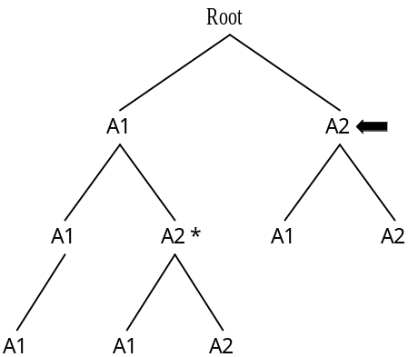

a) . \ A2\f b) .. \..\A2\f c) .. \A1\..\A2\f d) .. \A2\f

Q36. Which of the following corresponds to an element of a fault tolerant system?

a) RAID 0 b) Duplex hard disk
c) Schedule backup d) Data encryption
Q37. When comparing a distributed processing system, which consists of multiple computer systems located in a wide area, with centralized processing systems that operate in a single center, which of the following is a feature of centralized processing systems?

a) In the event of a disaster or a failure, recovery work can be conducted in a centralized fashion in the center, avoiding the risk of a long shutdown of the entire system.
b) Because the system is collectively managed, it is easy to satisfy requests for additions or changes to system functions, and the accumulation of backlog seldom occurs.
c) Data consistency is easily maintained and managed through the centralized implementation of measures in the center.
d) Although the operation and management of hardware and software resources is complex, expansion taking advantage of new technologies is easy.

Q38. Which of the following descriptions concerning the evaluation of system performance is correct?

a) For OLTP (Online Transaction Processing), the MIPS value is used to evaluate system performance.
b) Response time and turnaround time are indexes for evaluating performance from the standpoint of a system operations administrator.
c) It is common that response time is improved as the utilization of system resources becomes higher.
d) The number of transactions and jobs that can be processed within a unit of time is important when evaluating system performance.
Q39. Assume that there is a multiprocessor system consisting of four processors, A through D. When comparing the two operation conditions ① and ② below, approximately how many times is the availability under condition ① as high as the availability under condition ②? Assume that the availability ratio of each of the processors is 0.9, and that the availability ratio of system components other than the processors is 1.0.

[Operation Conditions]
① At least one processor (or more) needs to operate normally.
② All the processors must operate normally.

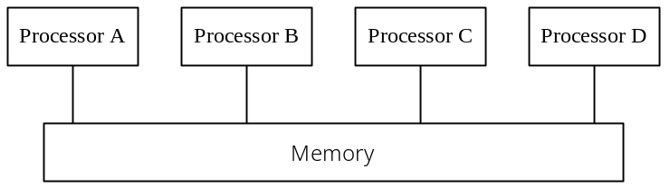

a) 0.5 b) 1.5 c) 3.0 d) 4.0

Q40. Which of the following is a correct description of a linker?

a) A linker registers created programs in a library.
b) A linker loads the load modules into main memory before the program is executed.
c) A linker monitors program execution and logs the execution results of each step of the program.
d) A linker combines the object modules, etc., into a single load module.

Q41. Which of the following is a language that defines the titles of documents, chapters, and sections; the elements of a document (such as figures and tables); and the relationships among them; and also has been adopted as a primary technology for CALS?

a) CGM b) MHS c) PostScript d) SGML
Q42. When the following CSV (Comma Separated Value) format data is inputted into spreadsheet software, and the calculation formulas indicated below are inserted in cells D1, D2, and D3, what value will be displayed in cell D3? When the CSV format data is inputted, the data is stored one by one in each cell in a horizontal row, starting from the left; when the line feed code (^{C}_{R}) is detected, the data is then inputted into the next row of cells, starting from the left. Assume that as soon as a value is inserted into a cell, the values in the other cells are recalculated immediately.

CSV format data : 2 , 2 , 4 ^{C}_{R} 1 , 3 , 4 ^{C}_{R} 2 , 1 , 1 ^{C}_{R}
Formula in cell D1 : A1 + C3
Formula in cell D2 : B1 + B3
Formula in cell D3 : D1 + D2

 | A | B | C | D
1
2
3

a) 6 b) 7 c) 8 d) 9

Q43. CASE tools can be classified according to the development processes or range to which they apply. Which of the following classifications includes the requirements specification analysis function?

a) Development platform b) Lower (stream)
c) Upper (stream) d) Maintenance
Q44. Which term describes the following type of diagram?

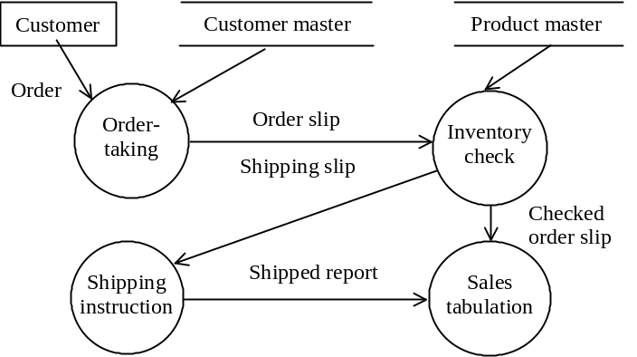

a) DFD b) State transition diagram c) Flowchart d) Petri net

Q45. Which of the following is the best description of a “structured chart,” a type of program diagram?

a) A structured chart can graphically express the hierarchy of logic, without having a means of expressing “GOTO.” This type of diagram is good for expressing the structure of logic within a module.
b) A structured chart is a tool that is widely used in the detailed design of control systems, etc. Because it cannot show the flow of data, it is reasonable to be used in combination with other types of diagrams.
c) A structured chart is a type of diagram that makes it easy to show the flow of data. It is not effective for showing the sequence of processes.
d) A structured chart consists of a graphical table of contents showing the module structure diagram and the diagrams each of which represents each module’s functions as input, process, and output. It is a diagram suitable for top-down design that is a feature of structured method.
Q46. Which of the following is a correct explanation of a state transition diagram?

a) A state transition diagram describes the overall structure of a program in a hierarchical structure.
b) A state transition diagram describes the operation of a program on the basis of the passage of time and changes in status.
c) A state transition diagram describes the functions of a system, proceeding stepwise from the general to the specific.
d) A state transition diagram describes the flow of data during processes using four symbols, i.e. data flow, process, data store and source/sink.

Q47. Which of the following is a correct description concerning object orientation?

a) In an object-oriented model, object operations to be abstracted must be specified beforehand.
b) Mutual dependency between objects can be increased by means of encapsulation.
c) When a class is changed, all the classes above that class must be changed.
d) When expanding or changing a model, the changed portion can be localized through the concept of inheritance.
Q48. Company A decided to conduct a study of its loyal customer segment. A “loyal customer” is defined as a customer who had recently made a purchase and who had made frequent purchases in the past. In order to determine the extent of the loyal customer segment within its customer base, the company decided to prepare an analysis table counting by period and by frequency the number of customers who have made purchases within the last month, the last two months, the last three months, and so on. Which of the following analysis tables is best for easily determining the extent of the loyal customer segment?

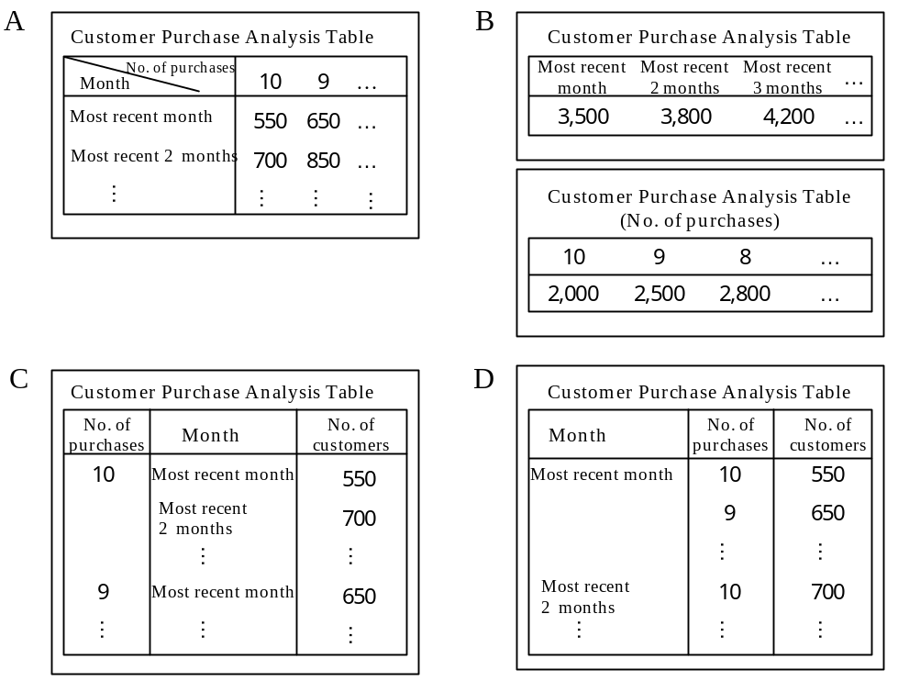

Q49. Of the following software test methods, which is used to check whether a change that was made for the purpose of software maintenance has any effect on other parts of the software?

a) Operation test b) Integration test
c) System test d) Regression test
Q50. Which of the following terms describe a process in which the author of a design and several other key persons review each design at its completion in order to discover design errors as early as possible?

a) Walkthrough b) Desk debugging
c) Topdown test d) Parallel simulation

Q51. The quality of a program was evaluated on the basis of a combination of coverage rate and error rate. Which of the following statements is the most suitable for the evaluation of a program that falls in the shaded portion of the diagram below?

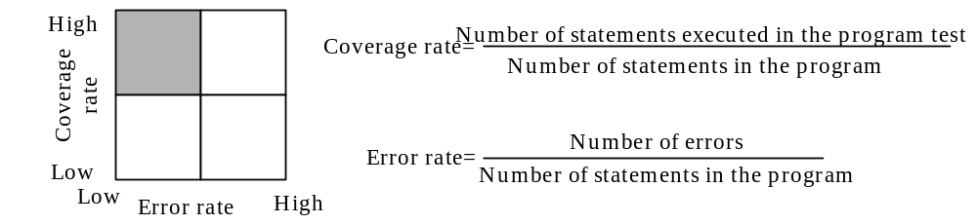

a) Generally, the program quality is deemed to be good, but it is necessary to confirm whether exception processing was included in the test items or not.
b) Because the error convergence is unknown, no judgement of program quality can be made by this evaluation method.
c) Because the rate of errors discovered is too low, it is likely that there is a problem with this evaluation method.
d) Because the coverage rate is high, the test is adequate. There is no need to continue further testing.
Q52. Using PERT, a plan for a system development project was created and the critical path was determined. Which of the following descriptions best explains what can be understood from the critical path?

a) The critical path makes it clear which tasks are the most important from the standpoint of system quality.
b) The critical path makes it clear which tasks can be conducted in a different sequence.
c) The critical path makes it clear which tasks are directly linked to delaying the entire project.
d) The critical path makes it clear which tasks entail the most costs.

Q53. The predicted effort for a given development project and the results achieved at the end of May are as follows:

 The total effort is 88 person months. A “person month” is the amount of work that a typical developers can accomplish in one month.
 The project period extends from January to August, and from January through May ten developers have been working on the project.
● Because the current developers are working at 20% lower efficiency than the typical developer, only 40 person months of work have been completed by the end of May, even though 50 person months have been devoted to the project.

How many developers need to be added to the project in order to complete the project on schedule by the end of August? Assume that any developers current or added since June will work with the same efficiency as that the current workers have been doing with. Also assume that the addition of new developers will not cause a drop in productivity.

a) 5 b) 10 c) 15 d) 20
Q54. Which of the following terms refers to the practice of subcontracting work such as system implementation, operation and administration to an outside firm?

a) Outsourcing b) Open system
c) Down-sizing d) Right sizing

Q55. The server in Company A’s order entry system has a 120GB hard disk. Which of the following is the best media for making weekly backups of the data base that occupies 10% of the hard disk? Assume that the backup software has a 50% compression rate when backing up the data.

a) 3.5” MO disk b) CD-R
c) DAT d) ZIP

Q56. Which of the following is an appropriate reason for adding a check digit to customer codes?

a) To detect input errors in customer codes.
b) To be able to order the customers in the sequence in which they were obtained when creating a ledger of customer accounts.
c) To facilitate the grouping of customers by region.
d) To be able to infer specific customers.
Q57. Which of the following approaches is appropriate regarding the disposal of data stored on magnetic tape?

a) Because there was data in the control register for which the storage period had already elapsed, that data was disposed of immediately, and then the prescribed procedures were followed thereafter.
b) Because the outside contractor that was hired to dispose of important data was a contractor that had been used previously by the company, no confirmation was made of the disposal method, etc.
c) Despite the additional effort entailed, data that was rendered unusable due to some fault was also disposed of according to the prescribed procedures.
d) After disposal, the data was deleted from the control master register, and for the sake of security no record was kept of the data in question.

Q58. A computer system consisting of a main unit, a display, a printer, and a modem is used for an average of three hours per day, thirty days per month. What is the cost of the electricity needed to power the system per month? Assume that the main unit consumes 200W, the display 140W, the printer 355W, and the modem 5W. Also assume that electricity costs 25 cents per kilowatt hour. Do not consider any basic charges, etc., for the electricity.

a) 63 b) 525 c) 765 d) 1,575

Q59. Which of the following statements concerning the confirmation of results in the course of system maintenance is correct?

a) Results are always confirmed through tests and with measuring equipment, not by human judgement.
b) The item which had a fault but automatically recovered can be excluded from the items to be confirmed.
c) Once the results of fault maintenance have been confirmed, the causes are studied and analyzed, and are reflected in a preventive maintenance plan.
d) The maintenance completion report is simplified to the extent that it is possible to confirm only that maintenance work was performed.
Q60. Which of the following correctly represents the relationship of TCP and IP used as protocols on the Internet, with the seven layers of the OSI Basic Reference Model?

 |  | A |  | B |  | C |  | D
Transport layer |  | IP |  |  |  | TCP
Network layer |  | TCP |  | IP |  | IP |  | TCP
Data link layer |  |  |  | TCP |  |  |  | IP

Q61. The character “T” (ASCII 7-bit code 1010100) was sent in a data transfer using start-stop synchronization with even parity error detection. If the character is received correctly, what will be the bit string that is received? Assume that the bits are sent in the following order: start bit (0); the character code, from least significant bit to most significant bit; parity bit; and stop bit (1). The bits are written in the sequence in which they are received, starting from the left.

a) 0001010101 b) 0001010111 c) 1001010110 d) 1001010111

Q62. Assuming that a high-quality digital network is being used, which communications service achieves high-speed communications by discarding the data in question when a data transfer error is detected within the network, and leaving retransmission control to the user?

a) Line switching service b) Leased line service
c) Packet switching service d) Frame relay service

Q63. How many seconds does it take to send a 10⁶-byte file over a 64 kbps line? Assume that the line transmission efficiency is 80%.

a) 19.6 b) 100 c) 125 d) 157
Q64. Which of the following descriptions concerning 10BASE5 is correct?

a) The maximum transmission distance is 5 km.
b) The maximum transmission speed is 10 Mbps.
c) Data is transmitted over twisted-pair cables.
d) Transmission is handled over a broad–band system.

Q65. Which of the following descriptions concerning connection equipment between LANs is correct?

a) A gateway is used for protocol conversion in the first through third layers of the OSI Basic Reference Model.
b) A bridge relays frames on the basis of IP addresses.
c) A repeater extends transmission distances by amplifying signals between segments of the same type.
d) A router relays frames on the basis of MAC addresses.

Q66. Which of the following descriptions concerning the projection which is a relational operation is correct?

a) A new table is created from a table by selecting the tuples which match the given conditions.
b) A new table is created by extracting only the specified attributes from a table.
c) A new table is created by selecting the tuples which are common to two tables.
d) A new table is created from a pair of tables by linking the tuples which match the given conditions.
Q67. What is the resulting data that is returned by executing the following SQL statement on the tables “STUDENT” and “DEPT” below?

SELECT NAME FROM STUDENT,DEPT
WHERE BELONG_TO = DEPT_NAME AND LOCATION ='SHINJUKU'

STUDENT DEPT
NAME | BELONG_TO | ADDRESS |  | DEPT_NAME | LOCATION
Mary Brook | Science | Shinjuku |  | Science | Shinjuku
John Smith | Engineering | Shibuya |  | Engineering | Shinjuku
Jim Dinkey | Humanity | Shibuya |  | Humanity | Shibuya
Susan Regan | Economics | Shinjuku |  | Economics | Shibuya

a) Mary Brook b) Mary Brook c) Mary Brook d) Mary Brook
John Smith Susan Regan John Smith
Susan Regan

Q68. Which of the following is correct as the processing that is performed at checkpoints by a DBMS?

a) The DBMS creates a list of transactions that should be re-executed.
b) The DBMS writes the contents of the data base update buffer onto the data base.
c) The DBMS writes out the transaction completion log.
d) The DBMS writes the contents of the log buffer onto the log file.

Q69. Which of the following descriptions concerning DBMS transactions is correct?

a) A transaction is completed by executing either COMMIT or ROLLBACK.
b) A transaction is a unit of file I/O.
c) A transaction cannot be used as a unit for failure recovery.
d) The consistency of data base operations cannot be guaranteed in an environment in which multiple transactions are executed simultaneously.
Q70. Which of the following encryption methods is classified as a common key cryptograph method?

a) DES b) RSA
c) ElGamal cryptograph d) Elliptic curve cryptosystem

Q71. Which of the following descriptions concerning security on the Internet is correct?

a) When using a data base server via the Internet, measures must be taken to prevent illegal access to the data base and falsification of data.
b) When sending e-mails via the Internet, the arrival of the e-mail can be confirmed as long as the e-mail has been encrypted.
c) In order to be able to use the Internet, a user must register in a user authentication system.
d) Even if a company’s internal e-mail system is connected to outside networks through the Internet, the transmission of confidential company information to a recipient who is outside the company can be automatically prevented by installing a firewall.

Q72. Which of the following descriptions of EUC codes is correct?

a) EUC codes are based on an ANSI standard. Each character code consists of 7 bits, with the 8th bit used as a parity bit.
b) EUC codes are 8-bit codes that were developed by IBM and are primarily used in mainframe computers.
c) EUC codes are two-byte codes that are primarily used with UNIX, and are capable of representing Chinese characters.
d) EUC codes are 2-byte codes that were proposed by Apple Computer, Novell, and Microsoft, and are now an ISO standard.
Q73. Which of the following statements concerning basic principles of the structure of an organization is correct?

a) Because a member of an organization may receive instructions from more than one superior, it is important to build an organization that can accommodate this.
b) Instructions can be made to flow from top to bottom in a consistent fashion by dividing the organization into several layers and making responsibilities and authorities clear within each level.
c) An organizational system in which each individual member can be responsible for a specialized business process is not desirable. Harmony with others is important.
d) Although determining the extent of control is important, there is no number that is defined as the suitable number of subordinates that one superior can oversee. Therefore, it is best to have one person oversee as many subordinates as possible.

Q74. A person wishes to open a coffee shop, given the following conditions. How many customers must the coffee shop serve per seat per day in order to generate $1000 of profit per month?

Conditions
Sales per customer | 5 dollars
Variable costs associated with sales per each customer | 1 dollar
Fixed costs | 3,000 dollars / month
Number of days of operation per month | 20 days
Number of seats | 10 seats

a) 3.75 b) 4 c) 4.2 d) 5
Q75. When an ABC analysis is conducted on the products included in the following table, which product numbers will belong to the group which should be managed as Group A?

Product No. | Units sold annually | Unit price | Annual sales
1 | 110 | 2 | 220
2 | 60 | 40 | 2,400
3 | 10 | 4 | 40
4 | 130 | 1 | 130
5 | 10 | 60 | 600
6 | 1 | 25 | 25
7 | 10 | 2 | 20
8 | 150 | 2 | 300
9 | 20 | 2 | 40
10 | 50 | 1 | 50
Toal | 551 |  | 3,825

a) 1, 2 b) 2, 5 c) 2, 6 d) 4, 8

Q76. Which of the following descriptions concerning the application of management science techniques is proper?

a) The PERT technique is used to conduct reliability analysis of machinery.
b) The queuing model is used to analyze a business using financial statements.
c) Time series analysis is used to forecast product sales in the market.
d) The simplex method is used for product quality control.
Q77. Company A currently has sales of $100 million, and knows that sales will increase if they invest 10% of sales in advertising. They can expect sales to increase either by 10%, 15%, or 20%, with a probability of 0.25, 0.5, and 0.25, respectively. If they make this investment in advertising, what level of sales (in millions of dollars) can they expect?

a) 105 b) 110 c) 115 d) 120

Q78. "A" and "B" below are both algorithms for determining the value of the function Y = F(X) for X = 0 to 1 in steps of 0.0001. How will "A" compare with "B" in terms of the computation precision and computation time when implemented on a real computer?

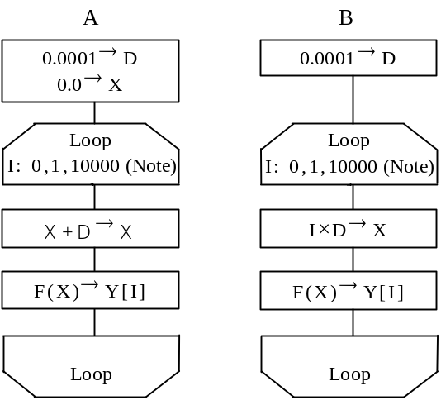
(Note) The loop specification is given in the
format "variable name: initial value,
increment, end value."

 | Computation precision | Computation time
a) | Higher | Longer
b) | Higher | Shorter
c) | Lower | Longer
d) | Lower | Shorter

Q79. The development of a system has been contracted out to an outside party with the following conditions. Which term below describes this type of agreement?

[Conditions]
(1) The outside party alone is completely responsible for completing the system.
(2) The outside party’s managers will direct and supervise the system development staff.
(3) The outside party may let some work to sub-contractors.

a) Commission b) Contract c) On loan d) Dispatch

Q80. Which of the following charts or diagrams is used to express work schedules and execution?

a) SD chart b) Venn diagram
c) Gantt chart d) Decision tree

